**Dual Stack**

**IPv4 and IPv6**

**Implementation**

Aditya engineering college |SURAMPALEM

Project documentation

2020

Mentor: Md. Shaifu Zama

Documentation by

***TEAM-1*:**

**Tarun Vamsi Krishna Chavatapalli**

**17A91A04I2**

**Sree Lasya Lagamsani**

**17A91A04K5**

**Rama Krishna Rohith Kankatala**

**17A91A04M0**



***AIM:***

To configure IPv6 in pre-configured IPv4 network.



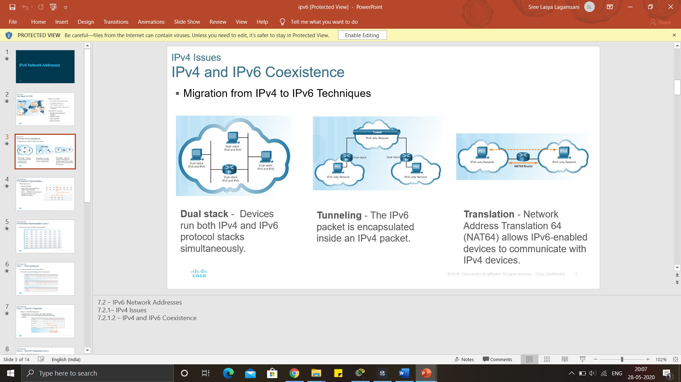**IP address**: An Internet Protocol address is a numerical label assigned to each device connected to a computer network that uses the IP for communication. An IP address serves two main functions: host or network interface identification and location addressing.

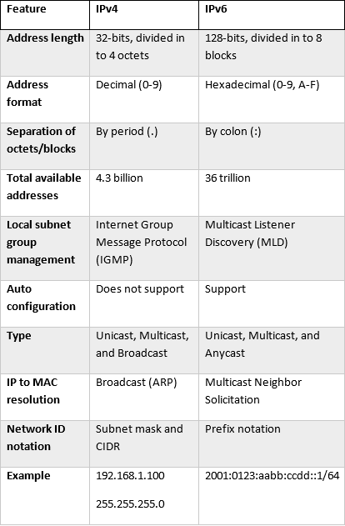

Differences between IPv4 and IPv6

**Dual-Stack**

* Dual-stack means that the device is able to run both IPv4 and IPv6 in parallel and allows hosts to simultaneously reach IPv4 and IPv6 content, so it offers a very flexible coexistence strategy.
* The dual-stack configured can be implemented on a single interface or multiple interfaces. In this configuration, the devices decide how to send the traffic based on the destination address of the other device

Needs of Dual-Stack

* The evolution of the Internet to IPv6 will directly affect enterprise customers because they will have to communicate with their customers, partners, and suppliers
* In order to ensure business continuity and future growth, all organizations need to carefully plan for coexistence between IPv4 and IPv6

Benefits of Dual-Stack

* Native dual stack does not require any tunnelling mechanism on internal networks.
* Both IPv4 and IPv6 run independent of each other

**About the Project**

ACOE campus recommended design for scalability and availability. A multi-Layer switch is used to manage Lab Networks and Cisco 1941 router used to manage different departments on the campus. These departments connect to the internet using the sub-interface concept of the router. NAT has been implemented for internet connectivity. The webserver and ISP act as a medium of internet connectivity in this simulation. Also, HSRP implemented for router redundancy. If any problem happens at the forwarding router, then the entire traffic would be automatically routed to the backup router and the user will still have connectivity to other departments and to the Internet without any downtime. And when the forwarding router comes online, the traffic again will be routed to forwarding router making backup router as standby. Though it has been implemented at a basic level, the topics, technologies, and protocols we have used in this scenario can be altered to design and recommend even better topology for campus networks to reduce connectivity and bandwidth problems

**Technologies and Protocols Used**

* "***VLAN***" - To completely reduce broadcasts in networks thus by tuning up network performance.
* "***Multilayer Switch***" - To avoid purchasing of expensive routers to route between multiple networks.
* "***Sub Interfaces***" - To avoid using multiple routers to route the traffic between different departments.
* "***HSRP***" - To make redundant links so that even if one router is down due to any reason, still the users will have connectivity to the Internet and other network resources.
* "***Trunk Links***" - To avoid using multiple cables to run between different VLANs that will make a mess with cabling infrastructure. In simple means, complete reduction of cabling infrastructure.

**NETWORK** 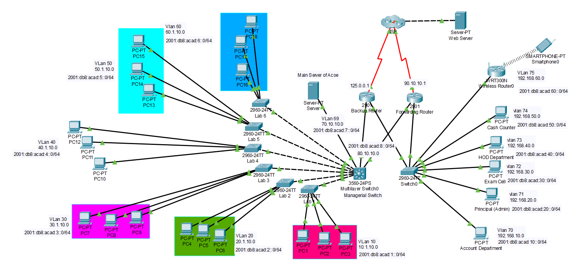

* ***VLAN****:*

**Configurations**

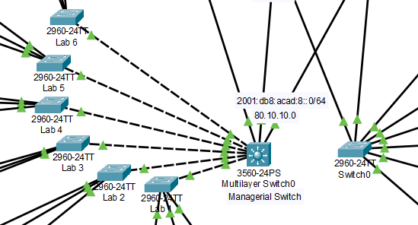

* A Virtual LAN (VLAN) is any broadcast domain that is partitioned and isolated in a computer network at the data link layer (OSI layer -2)
  + To connect both the switches in the same network assign the ports connecting the switches in the same VLAN in both the switches
  + By default the switches do not support ipv6 hence the 2960 must to be connected to server and copy the IOS version 15 from TFTP to flash and boot the system with IOS 15 to get support for ipv6

**Commands for VLAN:**

* To activate VLAN:
  + S1(config)#vlan “vlan number”
  + S1(config-vlan)#exit
* To assign ports to vlan:
  + S1(config)#interface “port” ex: interface fastEthernet 0/1
  + S1(config-if)#switchport access vlan “vlan_number”
* To check vlan :
  + S1#show vlan brief
* To assign IP to vlan:
  + S1(config)#interface vlan “vlan number”
  + S1(config)#ip address ‘ip_address’ ‘subnetmask’

S1(config)#ipv6 address ‘ipv6_address’/’subnet’

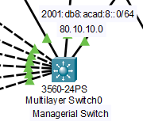

* ***Multi-Layer Switch***
* **It acts as layer 2 and layer 3 device and is capable of routing among VLANs.**
* **Dynamic routing can be configured in this device**
* **To enable dual stack in multilayer switch and traditional switch the following commands are used:**
  + **S(config)# sdm prefer dual-ipv4-and-ipv6 default**
  + **S(config)# exit**
  + **S# reload**
  + **S# show sdm prefer (to check about sdm)**
* **Then configure interfaces and assign IPv4 and IPv6 address.**

* ***Router on a stick***

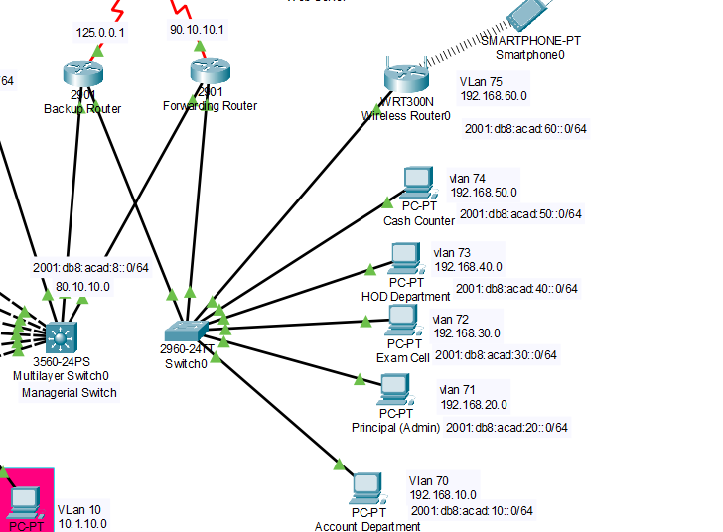

* Router is configured in such a way where sub-interfaces are used in router and trunking is used in a switch to reduce the connecting cables
  + Router>enable
  + Router#configure terminal
  + Enter configuration commands, one per line. End with CNTL/Z.
  + Router(config)#interface fastEthernet 0/0
  + Router(config-if)#no ip address
  + Router(config-if)#no shutdown
  + Router(config-if)#exit
  + Router(config)#interface fastEthernet 0/0.10
  + Router(config-subif)#encapsulation dot1Q ‘vlan number’
  + Router(config-subif)#ip address ‘ip_address’ ‘subnetmask’
  + Router(config-subif)#exit

***Dynamic Routing & Default Routing***

* Commands to configure dynamic routing:
* R(config)#router rip
* R(config)#version 2
* R(config)#network “network_id”
* commands to configure dynamic routing for ipv6 :
  + R(config)#interface “port”
  + R(config)#ipv6 rip “any_name” enable
* Commands to configure default routing(mustbe configured at the edge router of a network )
  + R(config)# ip route 0.0.0.0 0.0.0.0 “net_hop_address

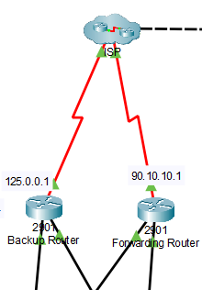

***Hot Standby***

***Routing Protocol***

This protocol is used to keep one router as a backup when another router fails in any case.

* R(config)# interface type number
* R(config)# ip address ip-address mask
* R(config)# standby ‘group-number’ priority ‘priority’
* R(config)# standby  ‘group-number’ preempt ‘delay’
* R(config)# standby ‘group-number’ ip ‘ip-address (secondary)’
* R(config)# end
* R(config)# show standby [all] [brief]

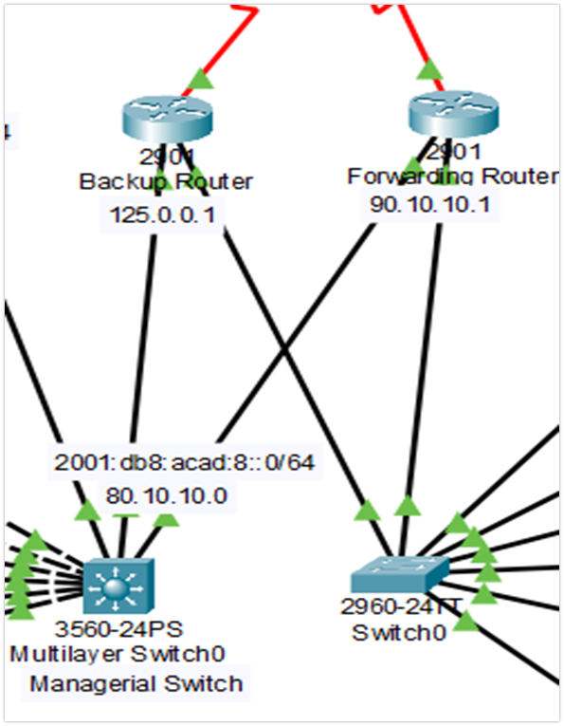

It is a set of rules that is usually used to filter network traffic. ACLs can be configured on network devices with packet filtering capability, such as routers and firewalls.

ACLs contains a list of conditions that categorize packets and help you determine when to allow or deny network traffic. They are applied on the interface basis to packets leaving or entering an interface. Two types of ACLs are available on a Cisco device:

* **Standard access lists** – allow you to evaluate only the source IP address of a packet. Standard ACLs are not as powerful as extended access lists, but they are less CPU intensive for the device.
* **Extended access lists** – allow you to evaluate the source and destination IP addresses, the type of Layer 3 protocol, source and destination port, and other parameters. Extended ACLs are more complex to configure and require more CPU time than the standard ACLs, but they allow more granular level of control.

***Access Control List (ACL)***

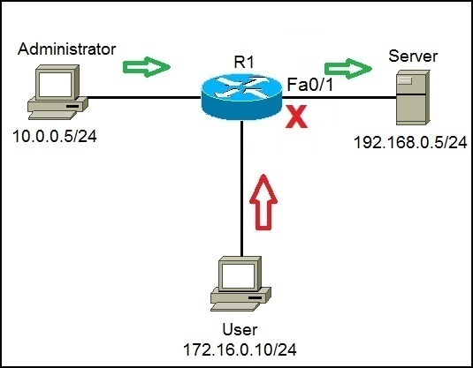

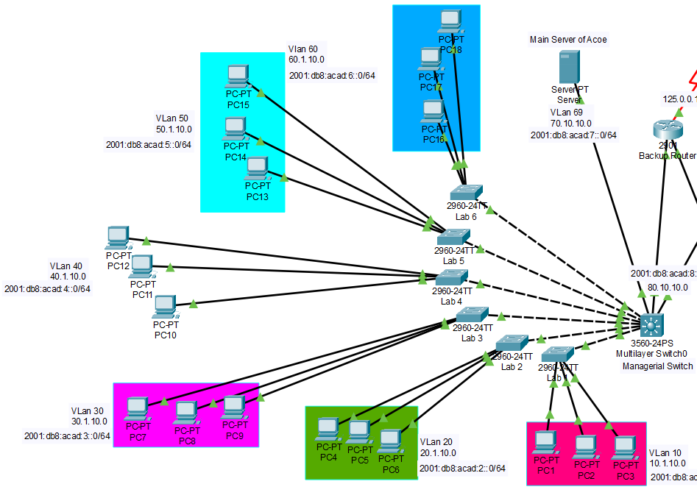

***Lab Network***

Lab networks are configured with ACL so the devices belong to lab network can’t access the internet but can route between devices in the switch level through multilayer switch. IPv6 can route when SDM and IPv6 unicast routing is enabled in the multilayer switch and enable SDM in switch to support IPv6 configuration.

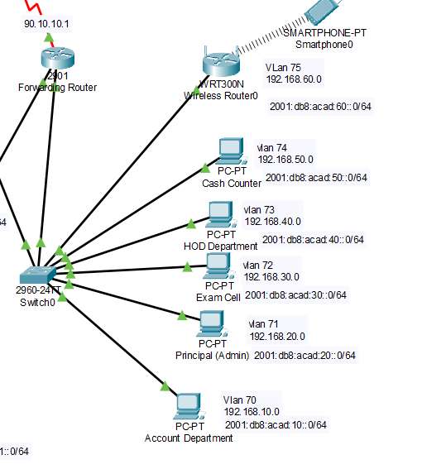

***Department Network***

Department networks can directly access the internet and they are configured to use the method router on a stick. IPv6 can route only when unicast routing is enabled in the router

***Network Configurations***

|  |  |  |  |  |  |  |
| --- | --- | --- | --- | --- | --- | --- |
| Device Name | Interface | VLAN | IPv4 Address | IPv6 Address | Connecting Devices | |
| Device Name | Interface |
| Managerial Switch | fa 0/1 | 80 | 80.10.10.1/8 | 2001:db8:acad:1::1/64 | Forwarding router | G0/0 |
| fa 0/10 | 80 | 80.10.10.1/8 | 2001:db8:acad:1::1/64 | Backup Router | G0/0 |
| fa 0/2 | 60 | 60.1.10.1/8 | 2001:db8:acad:6::1/64 | Lab 6 switch | fa 0/1 |
| fa 0/3 | 50 | 50.1.10.1/8 | 2001:db8:acad:5::1/64 | Lab 5 switch | fa 0/1 |
| fa 0/4 | 40 | 40.1.10.1/8 | 2001:db8:acad:4::1/64 | Lab 4 switch | fa 0/1 |
| fa 0/5 | 30 | 30.1.10.1/8 | 2001:db8:acad:3::1/64 | Lab 3 switch | fa 0/1 |
| fa 0/6 | 20 | 20.1.10.1/8 | 2001:db8:acad:2::1/64 | Lab 2 switch | fa 0/1 |
| fa 0/7 | 10 | 10.1.10.1/8 | 2001:db8:acad:1::1/64 | Lab 1 switch | fa 0/1 |
| fa 0/8 | 69 | 70.10.10.2/8 | 2001:db8:acad:7::1/64 | ACoE main server | fa 0/1 |
| Lab 1 Switch | fa 0/1 | Vlan 10 | 10.1.10.2/8 | 2001:db8:acad:1::2/64 | Managerial Switch | fa 0/7 |
| fa 0/2 | PC 1 | fa 0 |
| fa 0/3 | PC 2 | fa 0 |
| fa 0/4 | PC 3 | fa 0 |
| Lab 2 Switch | fa 0/1 | Vlan 20 | 20.1.10.2/8 | 2001:db8:acad:2::2/64 | Managerial Switch | fa 0/6 |
| fa 0/2 | PC 1 | fa 0 |
| fa 0/3 | PC 2 | fa 0 |
| fa 0/4 | PC 3 | fa 0 |
| Lab 3 Switch | fa 0/1 | Vlan 30 | 30.1.10.2/8 | 2001:db8:acad:3::2/64 | Managerial Switch | fa 0/5 |
| fa 0/2 | PC 4 | fa 0 |
| fa 0/3 | PC 5 | fa 0 |
| fa 0/4 | PC 6 | fa 0 |
| Lab 4 Switch | fa 0/1 | Vlan 40 | 40.1.10.2/8 | 2001:db8:acad:4::2/64 | Managerial Switch | fa 0/4 |
| fa 0/2 | PC 7 | fa 0 |
| fa 0/3 | PC 8 | fa 0 |
| fa 0/4 | PC 9 | fa 0 |
| Lab 5 Switch | fa 0/1 | Vlan 50 | 50.1.10.2/8 | 2001:db8:acad:5::2/64 | Managerial Switch | fa 0/3 |
| fa 0/2 | PC 10 | fa 0 |
| fa 0/3 | PC 11 | fa 0 |
| fa 0/4 | PC 12 | fa 0 |
| Lab 6 Switch | fa 0/1 | Vlan 60 | 60.1.10.2/8 | 2001:db8:acad:6::2/64 | Managerial Switch | fa 0/2 |
| fa 0/2 | PC 13 | fa 0 |
| fa 0/3 | PC 14 | fa 0 |
| fa 0/4 | PC 15 | fa 0 |
| Dept. Switch | fa 0/1 |  |  |  | Forwarding router | G 0/1 |
| fa 0/10 |  |  |  | Backup Router | G 0/1 |
| fa 0/2 | Vlan 70 | 192.168.10.1/24 | 2001:db8:acad:10::1/64 | Account Dept. | fa 0 |
| fa 0/3 | Vlan 71 | 192.168.20.1/24 | 2001:db8:acad:20::1/64 | Principal | fa 0 |
| fa 0/4 | Vlan 72 | 192.168.30.1/24 | 2001:db8:acad:30::1/64 | Exam Cell | fa 0 |
| fa 0/5 | Vlan 73 | 192.168.40.1/24 | 2001:db8:acad:40::1/64 | HOD | fa 0 |
| fa 0/6 | Vlan 74 | 192.168.50.1/24 | 2001:db8:acad:50::1/64 | Cash Counter | fa 0 |
| fa 0/7 | Vlan 75 | 192.168.60.1/24 | 2001:db8:acad:60::1/64 | Wireless Router | fa 0 |
| Forwarding Router | S 0/1/0 |  | 90.10.10.1/8 | 2001:db8:acad:90::1/64 | ISP | S 0/1/0 |
| G 0/0 |  | 80.10.10.2/8 | 2001:db8:acad:8::2/64 | Managerial Switch | fa 0/1 |
| G 0/1.70 |  | 192.168.10.3/24 | 2001:db8:acad:10::1/64 | Dept. Switch | fa 0/1 |
| G 0/1.71 |  | 192.168.20.3/24 | 2001:db8:acad:20::1/64 | Dept. Switch | fa 0/1 |
| G 0/1.72 |  | 192.168.30.3/24 | 2001:db8:acad:30::1/64 | Dept. Switch | fa 0/1 |
| G 0/1.73 |  | 192.168.40.3/24 | 2001:db8:acad:40::1/64 | Dept. Switch | fa 0/1 |
| G 0/1.74 |  | 192.168.50.3/24 | 2001:db8:acad:50::1/64 | Dept. Switch | fa 0/1 |
| G 0/1.75 |  | 192.168.60.3/24 | 2001:db8:acad:60::1/64 | Dept. Switch | fa 0/1 |
| Backup Router | S 0/1/0 |  | 125.0.0.1/8 | 2001:db8:acad:125::1/64 | ISP | S 0/1/1 |
| G 0/0 |  | 80.10.10.254/8 | 2001:db8:acad:8::254/64 | Managerial Switch | fa 0/10 |
| G 0/1.70 |  | 192.168.10.254/24 | 2001:db8:acad:10::254/64 | Dept. Switch | fa 0/10 |
| G 0/1.71 |  | 192.168.20.254/24 | 2001:db8:acad:20::254/64 | Dept. Switch | fa 0/10 |
| G 0/1.72 |  | 192.168.30.254/24 | 2001:db8:acad:30::254/64 | Dept. Switch | fa 0/10 |
| G 0/1.73 |  | 192.168.40.254/24 | 2001:db8:acad:40::254/64 | Dept. Switch | fa 0/10 |
| G 0/1.74 |  | 192.168.50.254/24 | 2001:db8:acad:50::254/64 | Dept. Switch | fa 0/10 |
| G 0/1.7 |  | 192.168.60.254/24 | 2001:db8:acad:60::254/64 | Dept. Switch | fa 0/10 |
| ISP | S 0/1/0 |  | 90.10.10.2/8 | 2001:db8:acad:90::2/64 | Forwarding Router | S 0/1/0 |
| S 0/1/1 |  | 125.0.0.2/8 | 2001:db8:acad:125::2/64 | Backup Router | S 0/1/1 |
| G 0/0 |  | 101.10.10.1/8 | 2001:db8:acad:101::2/64 | Web Server | fa 0 |

Conclusion :

IPv4 and IPv6 Dual stack implementation is successfully configured in a pre-configured IPv4 network.

Thank you